# Feature Tracker

Aim of this project was to track features in a series of image frames. MatLab software tool was used to implement the algorithm. The processing approach used in this project have two main tasks.

1. Detect the features from the first frame.
2. Follow the detected features from frame to frame in the series of image frames.

## Detecting Features

Harris corner detection is used to detect features for tracking.

$$det(M) - α · trace(M)2 ≥ τ$$

%%Find Ix and Iy with smoothing

dx =[-1 0 1 ; -1 0 1 ; -1 0 1];

dy =[-1 -1 -1 ; 0 0 0 ; 1 1 1 ];

Ix = imfilter(im,dx);

Iy = imfilter(im,dy);

%%finding gaussian filtered Ixx Iyy and Ixy

Ixx = imfilter(Ix.*Ix,gaussian);

Iyy = imfilter(Iy.*Iy,gaussian);

Ixy = imfilter(Ix.*Iy,gaussian);

%Corner response function

R= (Ixx.*Iyy - Ixy.^2) - k*(Ixx + Iyy).^2;

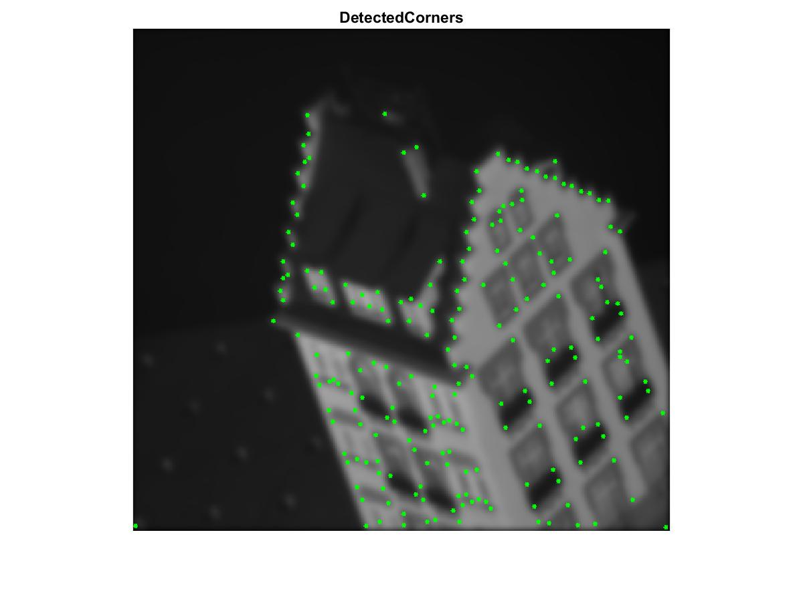

## Tracking Features